HADOOP FRAMEWORK DESCRIPTION

**Task1:**

Created a file max-temp.txt in local FS,

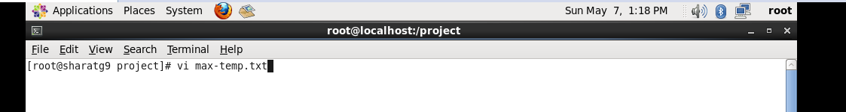

Inserted some records of date and temperature in max-temp.txt using vi editor mode.

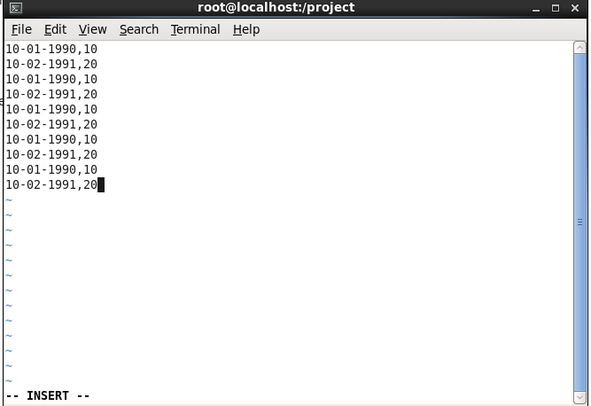

After Inserting saved the txt file using :wq command ,

And Moved saved file to HDFS at /user/acadgild/hadoop.

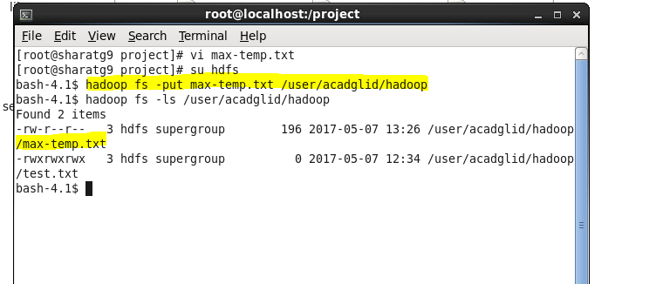

**Step 2:**

Changed the permission of the file /user/acadgild/hadoop/max-temp.txt using “chmod”

